**Practical No 5**

**Aim:** View cube data in multidimensional Format.

**Solution:**

1. Double Click on “SalesCube”. Go to the “Browser” Tab.

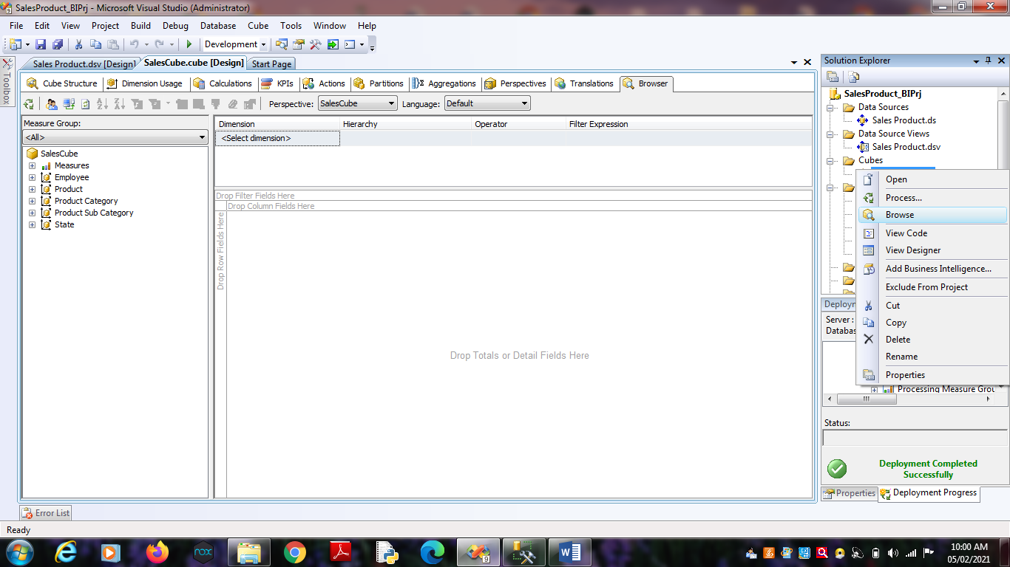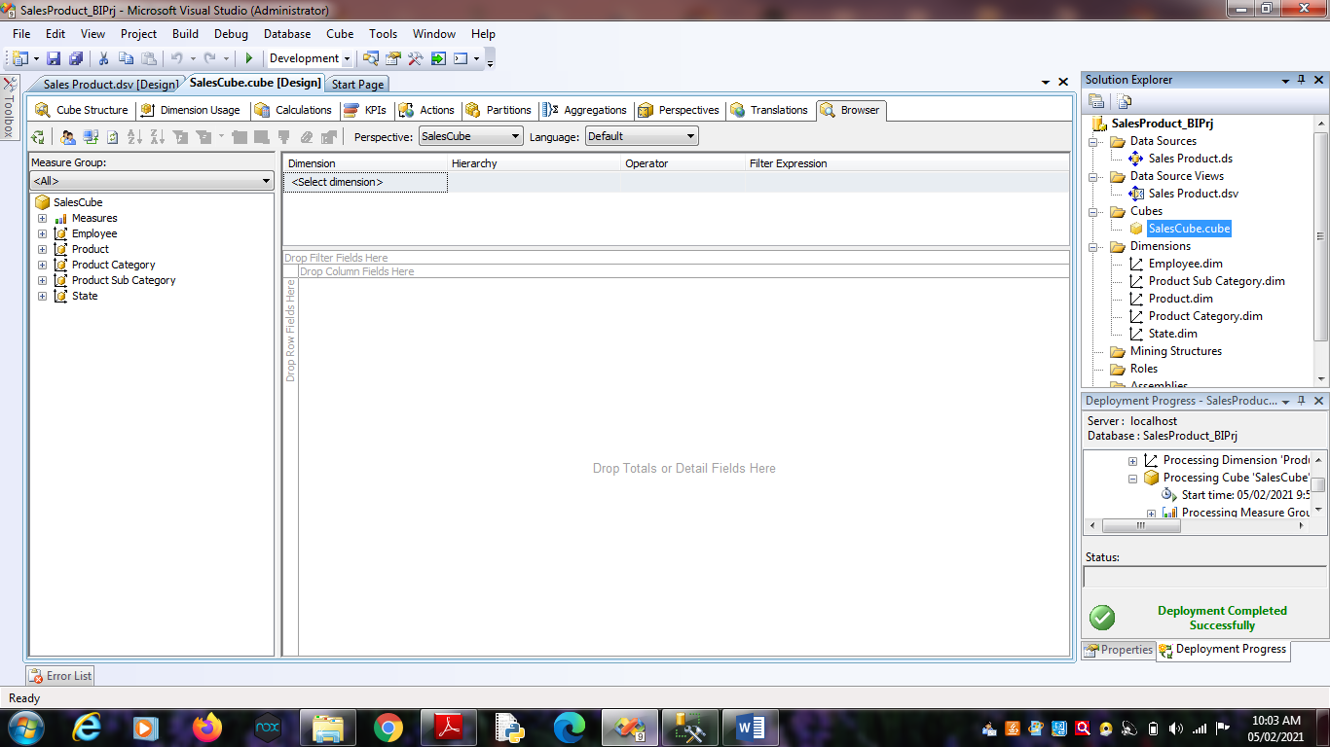2. Go to the “State Dimension”. Right Click on ‘State_ID’ -> Add to

Row Area.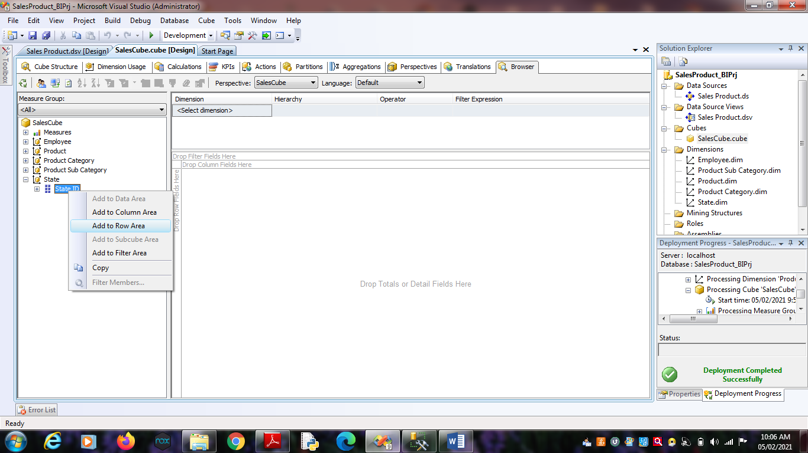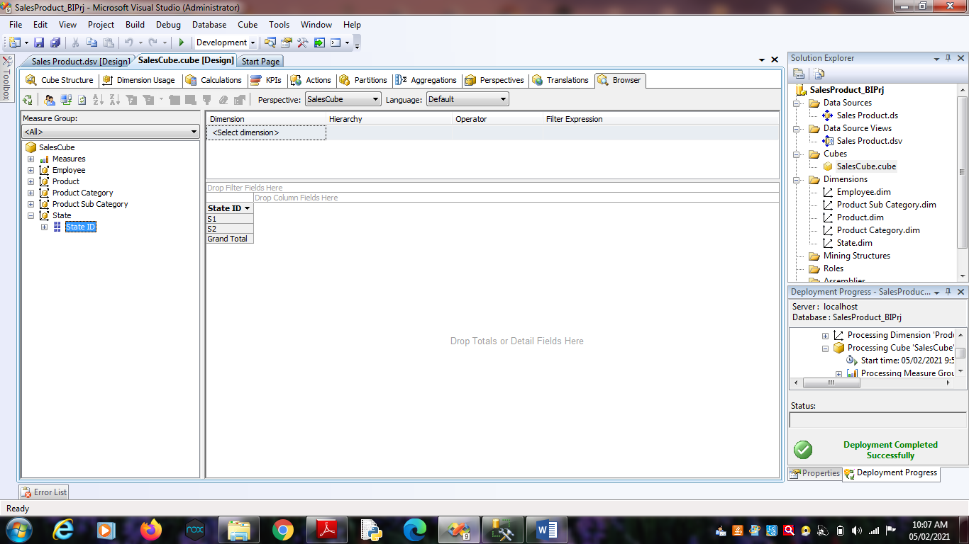 3. Go to the “Product Dimension”. Right Click on ‘Product_ID’ -> Add

to Column Area.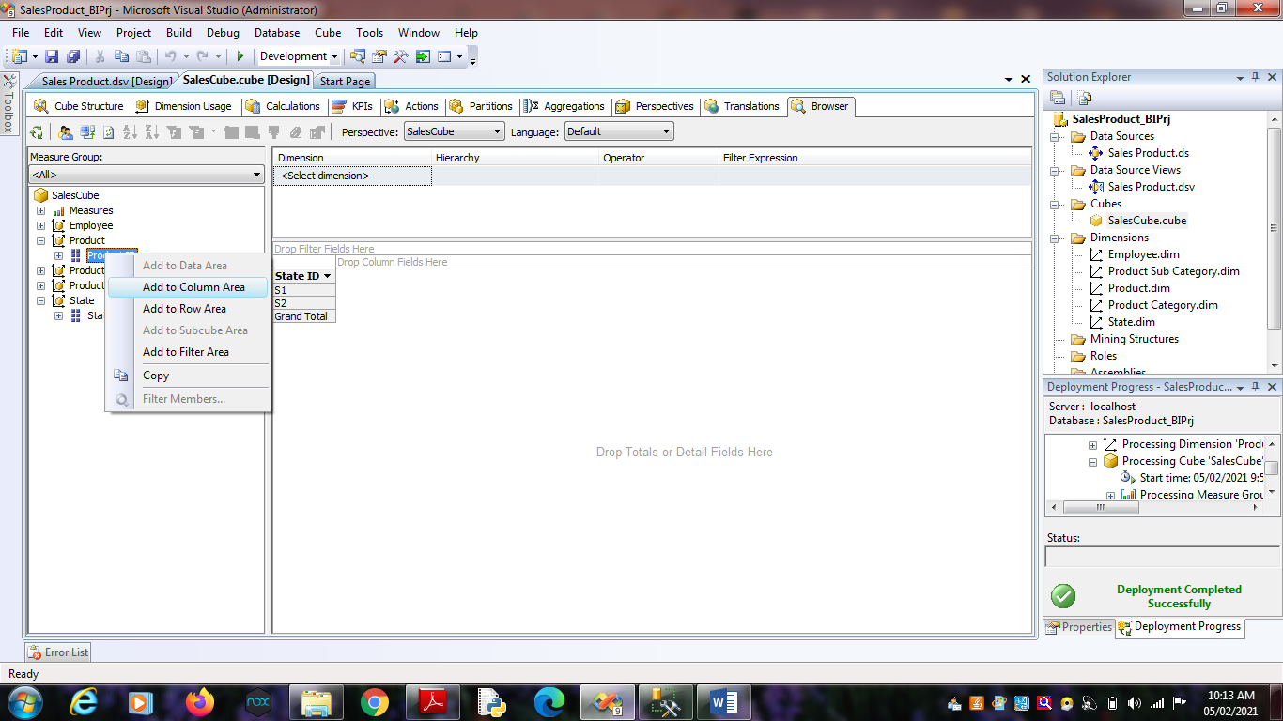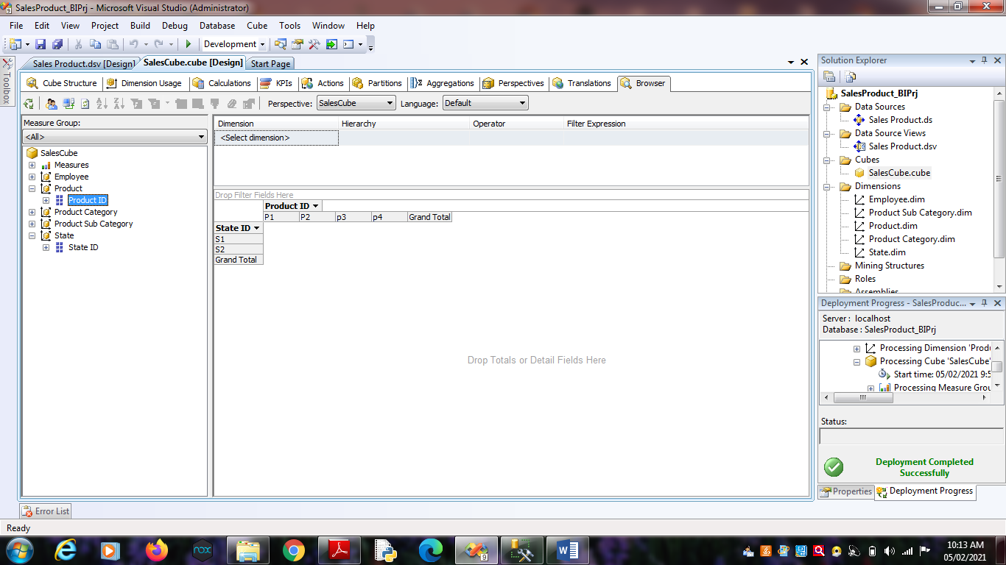 4. Go to ‘Measures’. Select ‘SalesFact’ -> Right Click on “Sales

Dollars” as well “Sales Units” -> Add to Data area.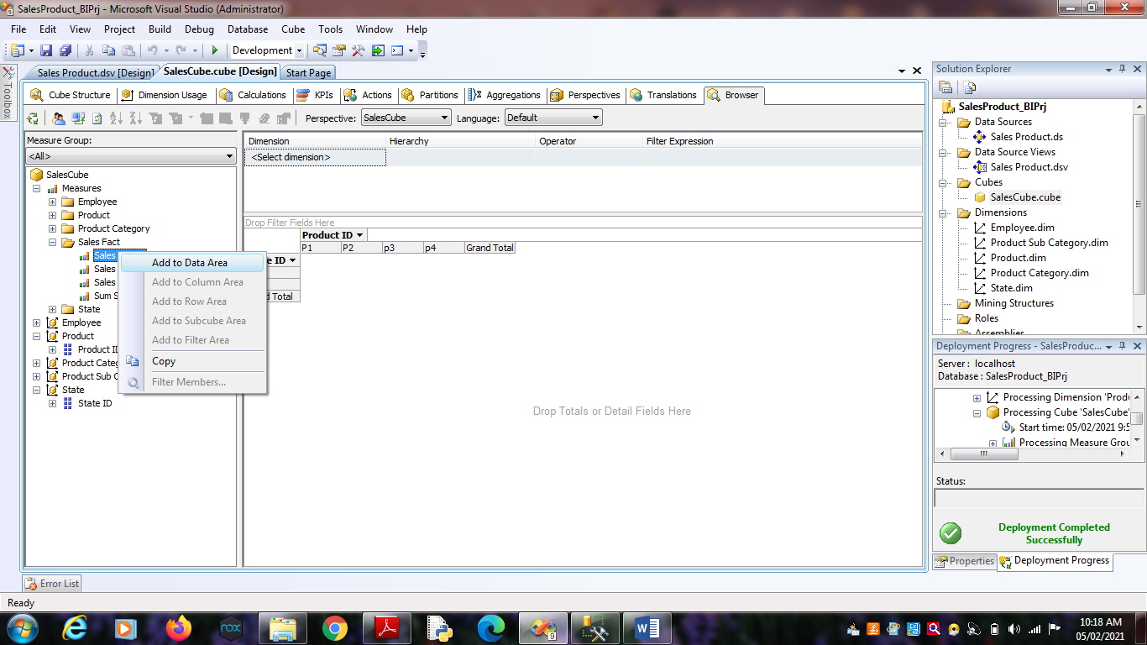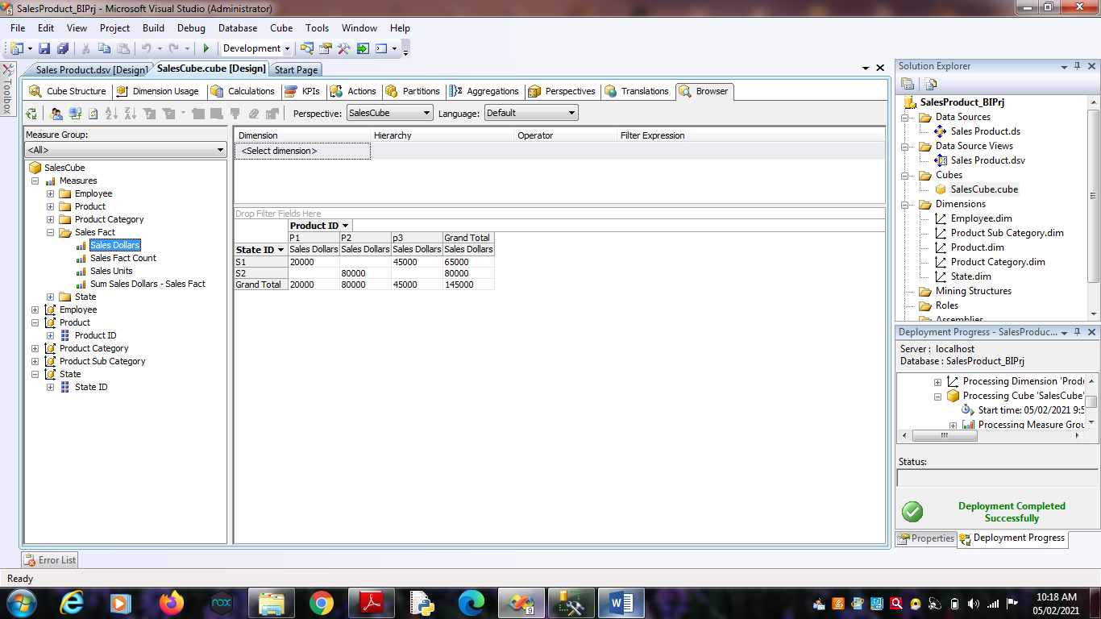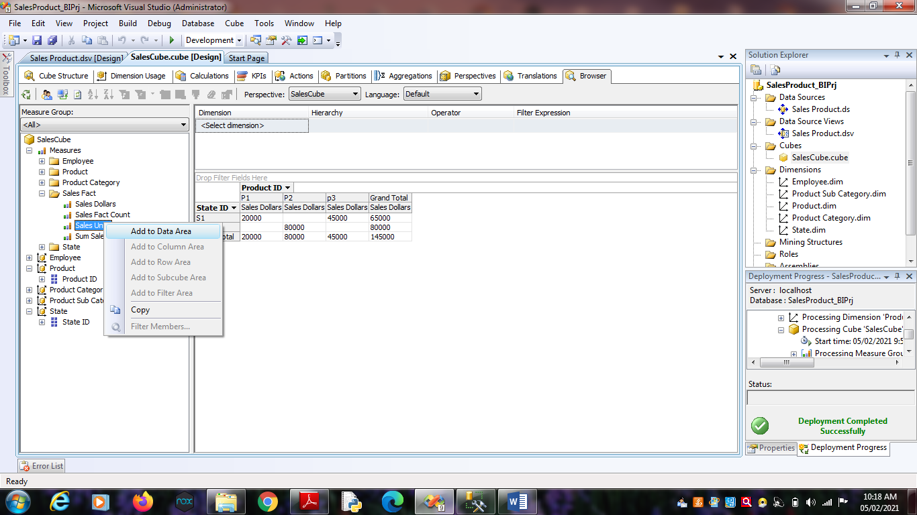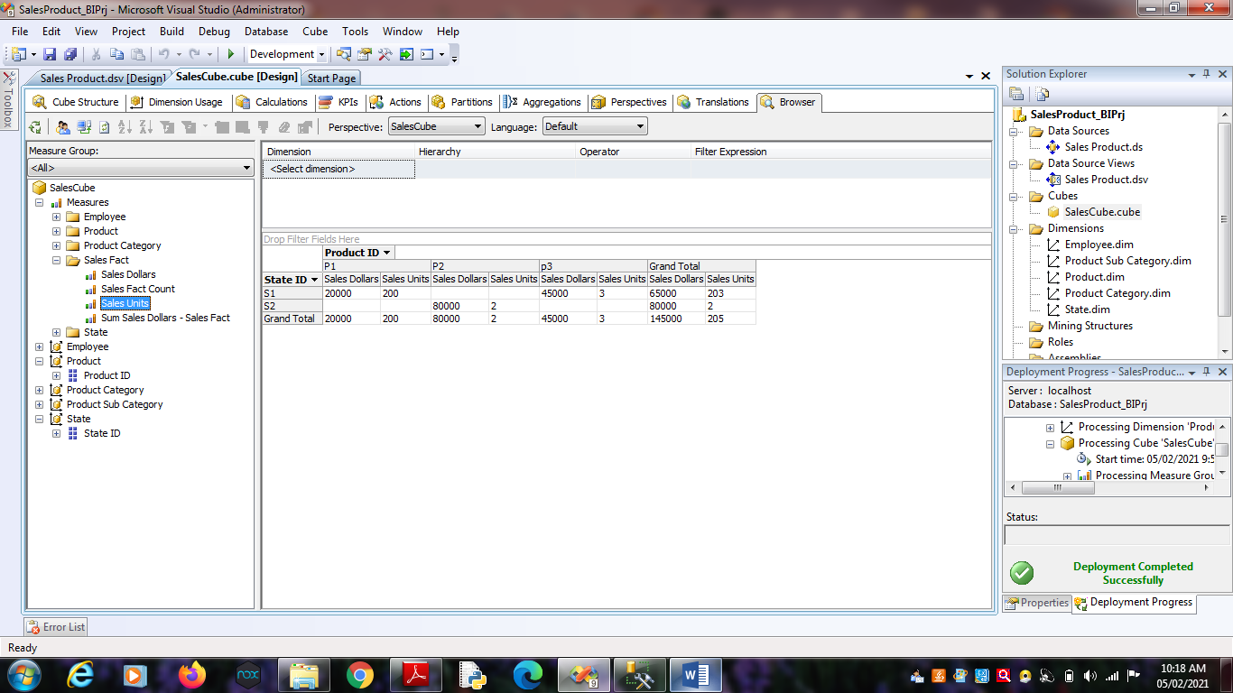 5. Go to the “Employee Dimension”. Right Click on ‘Employee_ID’ ->

Add to Row Area.